
B.N.M. Institute of Technology

An Autonomous Institution under VTU

VLSI DESIGN - DIGITAL
(23ECE163)

Assignment Report on

“UART Design using Cadence EDA Tools”

Akanksha V 1BG23EC006

Under the guidance of
Dr. Smitha Gayathri D
Associate Professor

Department of Electronics & Communication Engineering 2025-2026

INTRODUCTION
Universal Asynchronous Receiver Transmitter (UART) is one of the most widely used serial communication protocols in digital systems and embedded applications. It enables data transmission between devices using a simple asynchronous serial interface without requiring a shared clock signal between the transmitter and receiver. Because of its simplicity, reliability, and low hardware complexity, UART communication is commonly used in microcontrollers, embedded systems, computer peripherals, and communication interfaces such as GPS modules, Bluetooth modules, and serial debugging ports.
In a UART communication system, data is transmitted sequentially over a single data line. Each transmission frame typically consists of a start bit, a sequence of data bits, and a stop bit. The start bit indicates the beginning of transmission, followed by the data bits which are usually sent in Least Significant Bit (LSB) first order, and finally a stop bit that marks the end of the data frame. The transmitter converts parallel data into serial form and sends it through the communication line, while the receiver samples the incoming serial data and reconstructs the original parallel data.
In this project, a UART module consisting of both transmitter (TX) and receiver (RX) blocks is designed and implemented using Verilog Hardware Description Language (HDL). The design is modeled using finite state machines (FSMs) to control the transmission and reception processes. The transmitter generates the serial output signal based on the input data, while the receiver samples the incoming data and reconstructs the transmitted byte. A loopback configuration is used in the design where the transmitted data is internally connected to the receiver input to verify correct operation.
The design is simulated and verified using Cadence simulation tools. Functional verification is performed using a Verilog testbench that applies input stimulus and observes the output waveforms. The project demonstrates key digital design concepts such as sequential logic design, state machine implementation, serial data transmission, and timing-based sampling, which are fundamental in modern digital communication systems and VLSI design.

METHODOLOGY
BLOCK DIAGRAM:
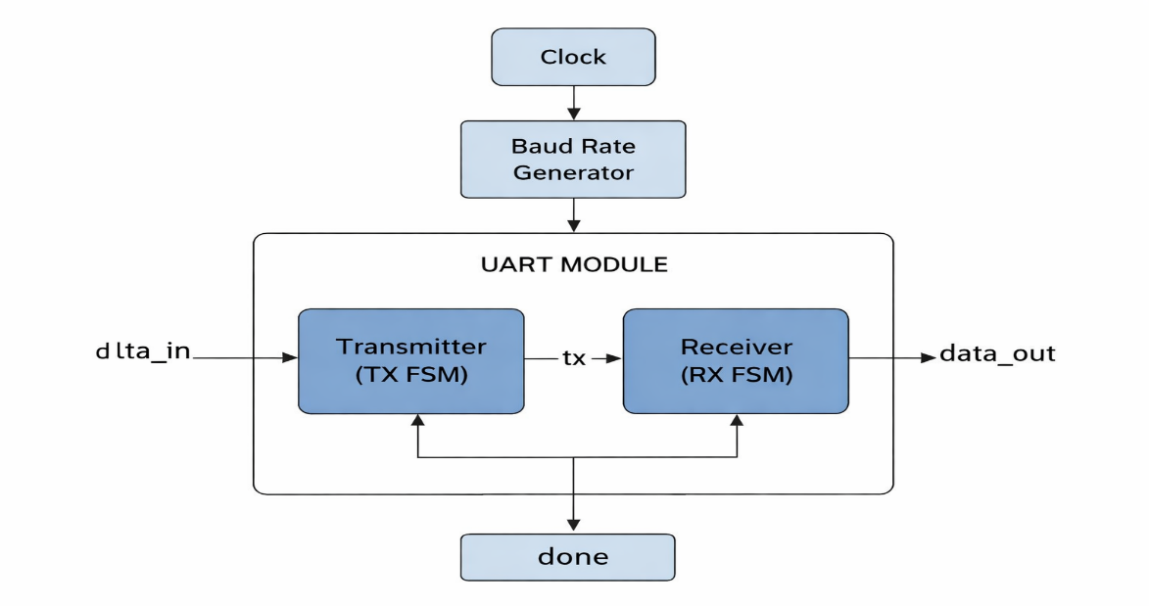
Fig 1. Block Diagram of a UART Protocol
The UART block diagram consists of two main components: the transmitter (TX) and the receiver (RX). The transmitter receives 8-bit parallel data (data_in) along with a start signal and converts it into serial data transmitted through the tx line. A clock signal controls the timing of the transmission. In this design, the transmitted signal is internally connected to the receiver using a loopback connection (rx = tx). The receiver samples the incoming serial data, reconstructs the original 8-bit data, and stores it in data_out. After the complete byte is received, the receiver generates a done signal indicating successful data reception.
A Verilog testbench was developed to verify the functionality of the design by providing clock, reset, start signal, and input data stimuli. The waveform results were observed to ensure correct transmission and reception of data. After functional verification, the design was synthesized using Cadence synthesis tools. The synthesis process included elaboration, generic synthesis, technology mapping, and optimization stages. Timing constraints such as clock period, input delay, output delay, and transition limits were applied to perform timing optimization and analyze area, power, and timing reports for the UART design.
SOURCE CODE
module uart (input clk, input rst, input start, input [7:0] data_in,
output reg [7:0] data_out, output reg done, output reg tx);
parameter CLKS_PER_BIT = 8;
// TX regs
reg [3:0] tx_bit_index; reg [7:0] tx_data_reg; reg [7:0] tx_clk_count;
reg [2:0] tx_state; reg busy;
// RX regs
reg [3:0] rx_bit_index; reg [7:0] rx_clk_count; reg [2:0] rx_state;
parameter IDLE=0, START=1, DATA=2, STOP=3;
wire rx;
assign rx = tx; // Loopback internally
// ---------------- TX LOGIC ----------------
always @(posedge clk or posedge rst) begin
if (rst) begin
tx_state <= IDLE;
tx <= 1; busy <= 0;
tx_clk_count <= 0; tx_bit_index <= 0;
end else begin
case(tx_state)
IDLE: begin
tx <= 1; busy <= 0;
if (start) begin
busy <= 1; tx_data_reg <= data_in;
tx_state <= START;
end
end
START: begin
tx <= 0;
if (tx_clk_count < CLKS_PER_BIT-1)
tx_clk_count <= tx_clk_count + 1;
else begin
tx_clk_count <= 0; tx_state <= DATA; tx_bit_index <= 0;
end
end
DATA: begin
tx <= tx_data_reg[tx_bit_index];
if (tx_clk_count < CLKS_PER_BIT-1)
tx_clk_count <= tx_clk_count + 1;
else begin
tx_clk_count <= 0;
if (tx_bit_index < 7)
tx_bit_index <= tx_bit_index + 1;
else
tx_state <= STOP;
end
end

STOP: begin
tx <= 1;
if (tx_clk_count < CLKS_PER_BIT-1)
tx_clk_count <= tx_clk_count + 1;
else begin
tx_state <= IDLE;
tx_clk_count <= 0;
end
end
endcase
end
end
// ---------------- RX LOGIC ----------------
always @ (posedge clk or posedge rst) begin
if (rst) begin
rx_state <= IDLE; done <= 0;
rx_clk_count <= 0; rx_bit_index <= 0;
data_out<=8'b00000000;
end else begin
case(rx_state)
IDLE: begin
done <= 0;
if (rx == 0)
rx_state <= START;
end
START: begin
if (rx_clk_count < (CLKS_PER_BIT/2))
rx_clk_count <= rx_clk_count + 1;
else begin
rx_clk_count <= 0; rx_state <= DATA; rx_bit_index <= 0;
end
end
DATA: begin
if (rx_clk_count < CLKS_PER_BIT-1)
rx_clk_count <= rx_clk_count + 1;
else begin
rx_clk_count <= 0;
data_out[rx_bit_index] <= rx;
if (rx_bit_index < 7)
rx_bit_index <= rx_bit_index + 1;
else
rx_state <= STOP;
end end
STOP: begin
done <= 1;
rx_state <= IDLE;
end endcase end
end endmodule
TEST BENCH CODE
module uart_tb;
reg clk; reg rst; reg start; reg [7:0] data_in;
wire [7:0] data_out; wire done; wire tx;
uart DUT (.clk(clk), .rst(rst),.start(start),.data_in(data_in),.data_out(data_out),
.done(done),.tx(tx));
always#5 clk = ~clk;
initial begin
clk = 0;
rst = 1;
start = 0;
data_in = 8'h00;
#20 rst = 0;
#20 data_in = 8'hA5;
start = 1;
#10 start = 0;
#1200;
$finish;
end
endmodule

WAVEFORM
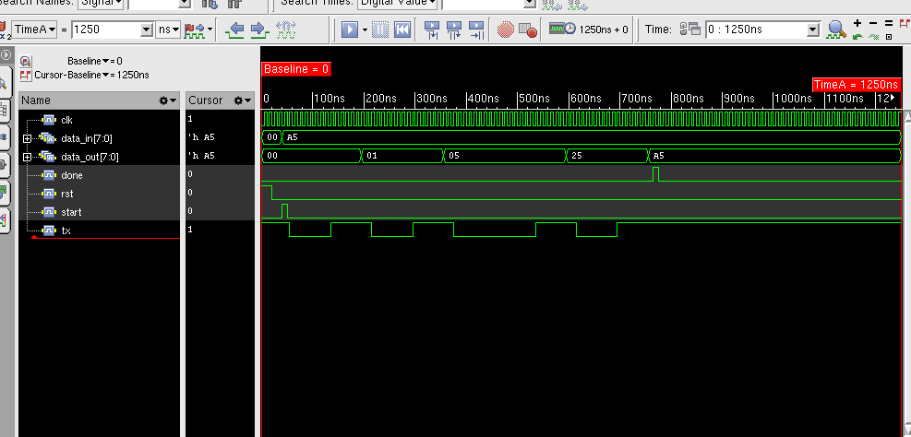
The simulation waveform shows the functional verification of the UART transmitter and receiver designed using Verilog. The main signals observed in the waveform are clk, rst, start, data_in[7:0], tx, data_out[7:0], and done.
Initially, the clock (clk) signal toggles continuously with a fixed period, providing synchronization for all sequential operations in the UART module. At the beginning of the simulation, the reset (rst) signal is asserted high, which initializes all registers and sets the transmitter to the idle state. During this time, the tx line remains high, which represents the idle condition of a UART communication line. After reset is de-asserted, the start signal is activated to begin data transmission.

The input data data_in = A5 (hexadecimal) is loaded into the transmitter register. The transmitter first generates a start bit (logic 0) on the tx line, indicating the beginning of a UART frame. This is followed by the transmission of the eight data bits sequentially from the least significant bit to the most significant bit. After the data bits are transmitted, a stop bit (logic 1) is generated, marking the end of the transmission.
Since the design uses an internal loopback connection where rx = tx, the receiver captures the transmitted serial data and reconstructs the original parallel data. The received values appear on data_out, which changes from 00 → 01 → 05 → 25 → A5, showing gradual reconstruction of the transmitted byte. Once the complete byte is received, the done signal becomes high, indicating successful reception of the transmitted data.

SYNTHESIS
Synthesis is the process of converting a hardware description written in Verilog or VHDL into a gate-level digital circuit. During synthesis, the HDL code is analyzed and translated into basic logic gates and flip-flops. The synthesis tool then maps these logic elements to the standard cells available in a technology library. Optimization techniques are applied to improve area, timing, and power performance. The final output of synthesis is a technology-mapped netlist that can be used for further implementation and physical design.
1.RTL Schematic (After Elaboration)
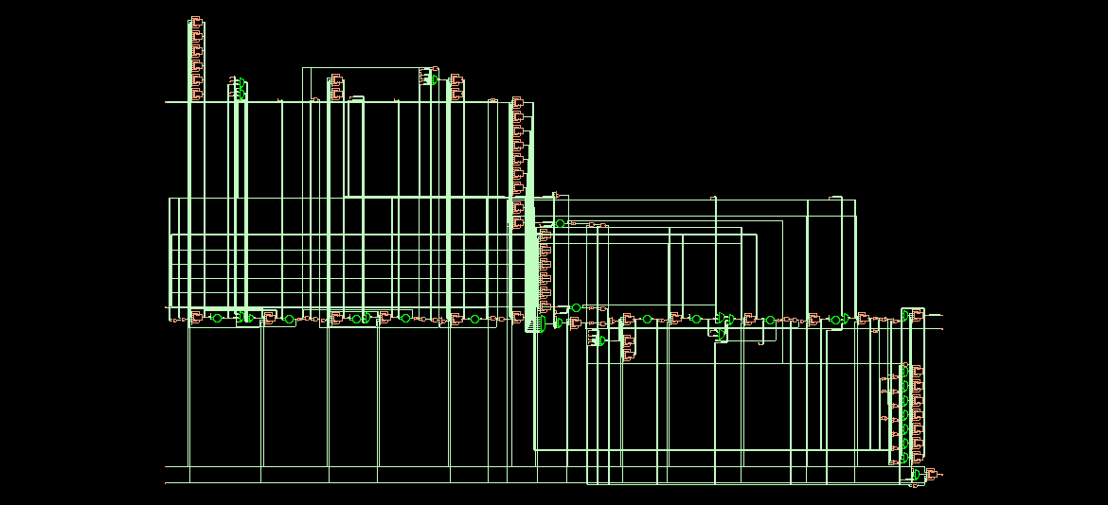
Fig 2.1 RTL Schematic of UART Design after Elaboration
This schematic shows the Register Transfer Level (RTL) representation of the UART design after the elaboration stage. The Verilog code is interpreted by the synthesis tool and converted into RTL blocks such as registers, multiplexers, and logic elements representing the functional structure of the design.
2. Generic Gate-Level Schematic
After the generic synthesis stage, the RTL design is converted into technology-independent logic gates such as AND, OR, NOT, and flip-flops. This representation shows the logical implementation of the design before mapping it to a specific technology library.
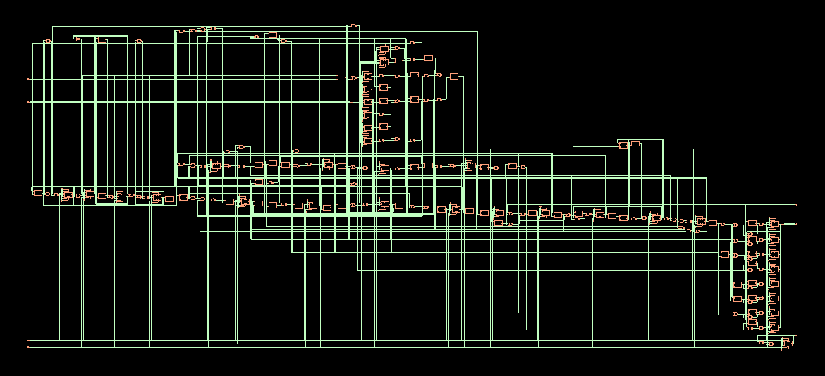
Fig 2.2 Generic Gate-Level Schematic of UART Design
3. Technology Mapped Schematic
In this stage, the synthesized design is mapped to the standard cells available in the technology library. Generic gates are replaced with actual standard cells like NAND, NOR, and flip-flops defined in the library used by the synthesis tool.
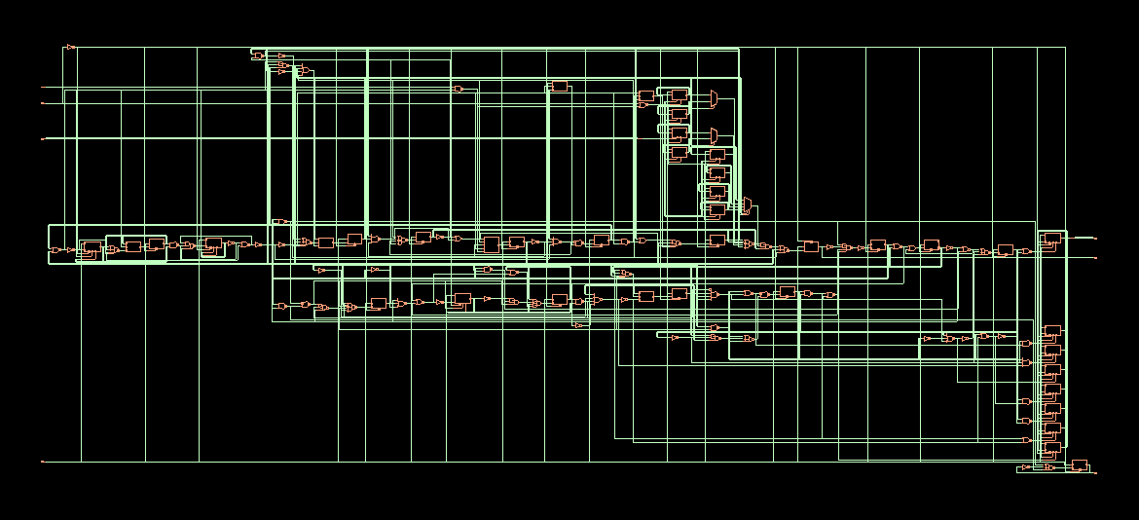
Fig 2.3 Technology Mapped Schematic of UART Design
4. Optimized Design after Applying Timing Constraints
After applying timing constraints such as clock period, input delay, output delay, and transition limits, the synthesis tool performs optimization to improve timing performance. The resulting schematic shows the optimized gate-level implementation that satisfies the specified timing requirements.
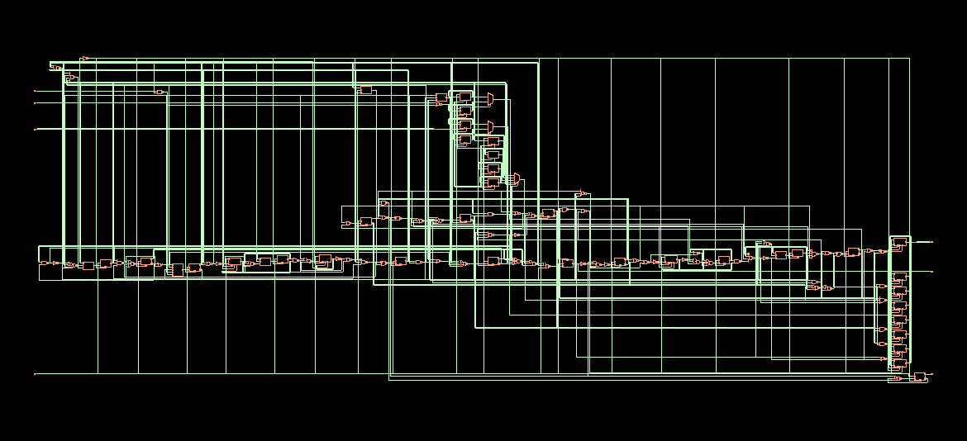
Fig 2.4 Optimized UART Design after Applying Timing Constraints
TIMING REPORTS
WITHOUT TIMING CONSTRAINTS:
1.AREA REPORT
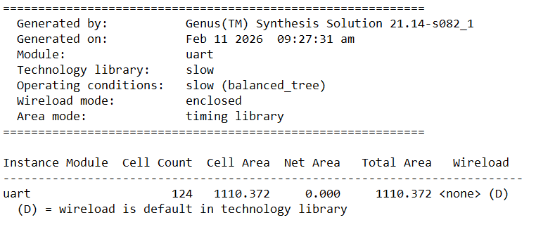
2.POWER REPORT
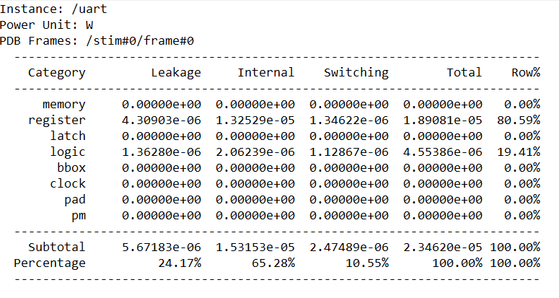
3.GATES REPORT
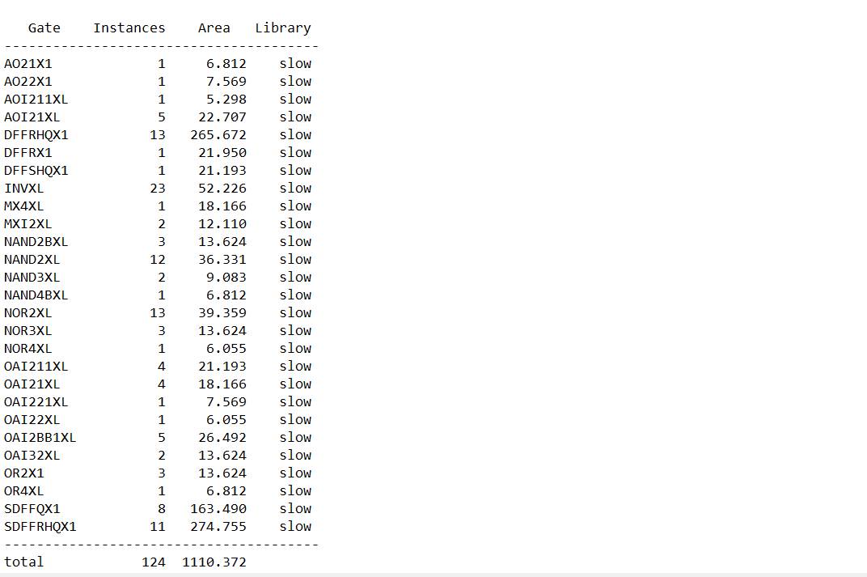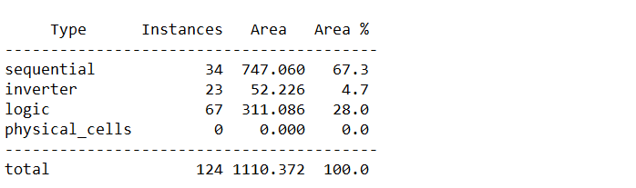
WITH TIMING CONSTRAINTS:
1.AREA REPORT
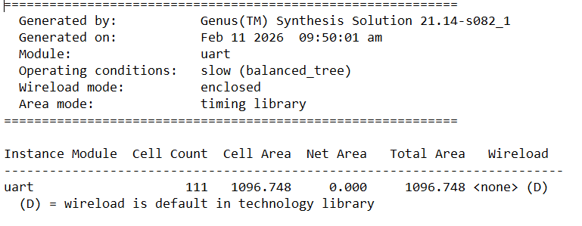
2.POWER REPORT
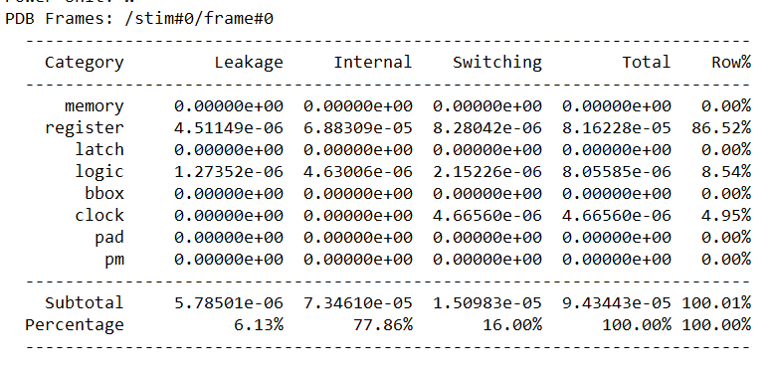
3.GATES REPORT
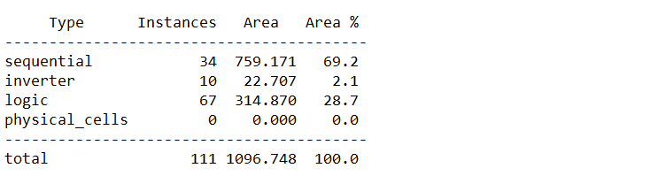
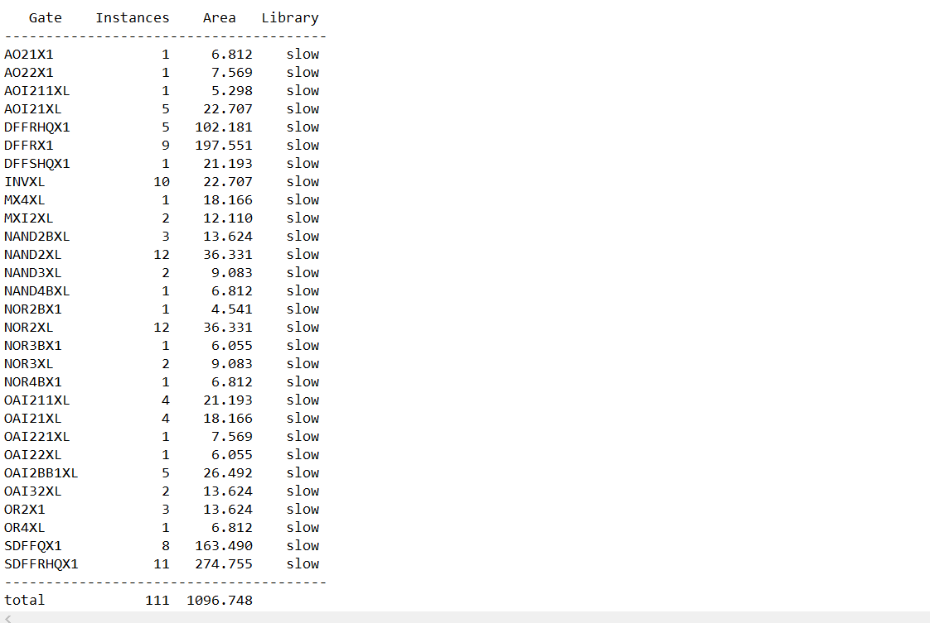
4.TIMING REPORT
